OFA Effective Conversations
Part 2: Know your why

Activity #1: Why is it difficult to persuade someone to change?

Listening to “This American Life,” and thinking of your own experiences, why is so difficult to change someone’s opinion?

Challenges to persuasion:

- Personal anxiety
- Interpersonal differences
- Fractured political context
- The ‘ask’ typically associated

Simon Sinek’s Framework:

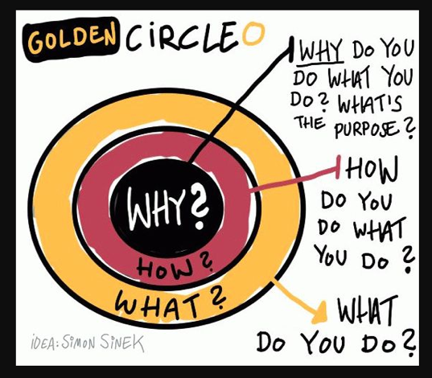

Activity #2: When you listen to the two cases, what feels different to you?

Critical incidents - “Events in your life that you recall being an important moment for you in clarifying what you believe.”
-- Stephen Brookfield

Activity #3: A framework to knowing your why:

Step 1 - Your critical incident

- When was the first time you remember standing up for something you believe in?

- When was the first time you saw something unjust?

- When do you remember feeling pride in something you worked hard for?

NOTES:

Step 2 - Root values

- Looking at your critical incident, what are the root values that you believe in?

NOTES:

Step 3 - Why is this important to you?

- Practice sharing your critical incident, as well as the root values that underlie it.

- How can you share this in a way that resonates deeply for others?

Activity #4: Synthesis

What changes will you make in conversations if you are trying to identify someone else’s why?

What changes will you make in conversations if you are trying to communicate your why?

RESOURCE #1: Values List (adapted from http://www.taproot.com/archives/37771):

Use this list of values to inform your critical incident -- which values resonate with your critical incident?

Abundance  Acceptance  Accountability Achievement  Advancement  Adventure  Advocacy  Ambition  Appreciation Attractiveness  Autonomy  Balance  Being the Best Benevolence  Boldness  Brilliance  Calmness  Caring  Challenge  Charity  Cheerfulness  Cleverness  Community  Commitment  Compassion  Cooperation  Collaboration  Consistency  Contribution  Creativity  Credibility  Curiosity | Daring  Decisiveness  Dedication  Dependability  Diversity  Empathy  Encouragement Enthusiasm  Ethics  Excellence  Expressiveness  Fairness  Family  Friendships  Flexibility  Freedom  Fun  Generosity  Grace  Growth  Flexibility  Happiness  Health  Honesty  Humility  Humor  Inclusiveness Independence  Individuality  Innovation  Inspiration  Intelligence | Intuition  Joy  Kindness  Knowledge  Leadership  Learning  Love  Loyalty  Making a Difference Mindfulness  Motivation  Optimism Open-Mindedness Originality  Passion  Performance  Personal Development Proactive  Professionalism  Quality  Recognition  Risk Taking  Safety  Security  Service  Spirituality  Stability  Peace  Perfection  Playfulness  Popularity  Power | Preparedness Proactivity Professionalism Punctuality Recognition Relationships Reliability  Resilience Resourcefulness Responsibility Responsiveness Security  Self-Control Selflessness Simplicity  Stability  Success  Teamwork Thankfulness Thoughtfulness Traditionalism Trustworthiness Understanding Uniqueness Usefulness  Versatility  Vision  Warmth  Wealth  Well-Being  Wisdom  Zeal

