Campaign Organizing Bootcamp
GOTV turnout conversations

Goals for this training:
- Internalize and apply the ‘get out the vote’ framework for effective conversations when talking to sporadic voters
- Examine ‘get out the vote’ best practices
- Feel excited to implement these practices with voters in your community

Activity: What is a turnout conversation and why is it important?

NOTES:

Why do turnout conversations work?
- Accountability to vote
  - Creates social pressure
- Pledging to vote
  - Reminds voters of the norm of voting
  - Voters who pledge to vote are more likely to turnout than those who don’t
- Vote planning
  - Vote planning effectively cuts through the quick yes/no responses you might get from voters

Understanding the audience for turnout:
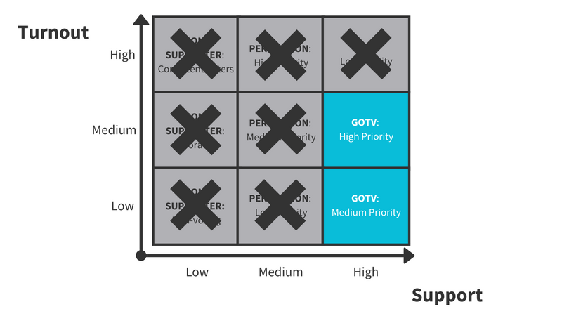
Elements of GOTV turnout conversation
- Getting a commitment
- Making a plan to vote

GOTV conversation framework
Step 1: Confirm their support for your cause and remind them of key voting deadlines
Step 2: Make a plan with the voter
Step 3: Get a commitment from the voter and ask them to verbalize their reasons
Step 4: Don’t focus on issues or candidates

Elements of a great GOTV script

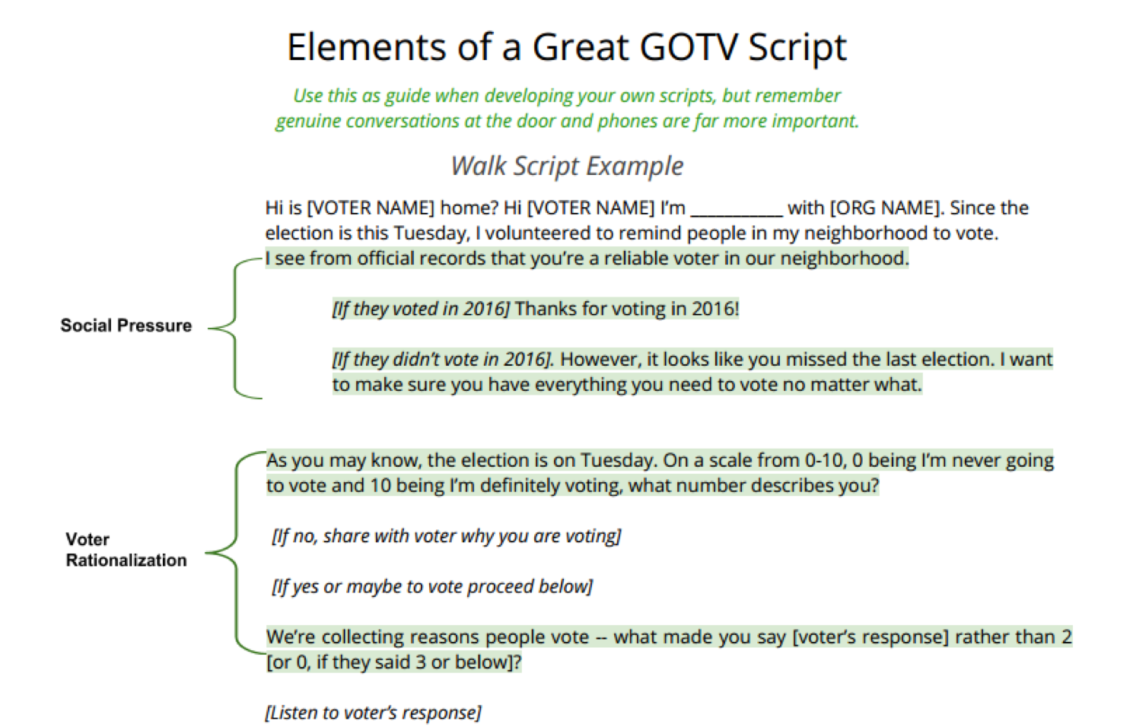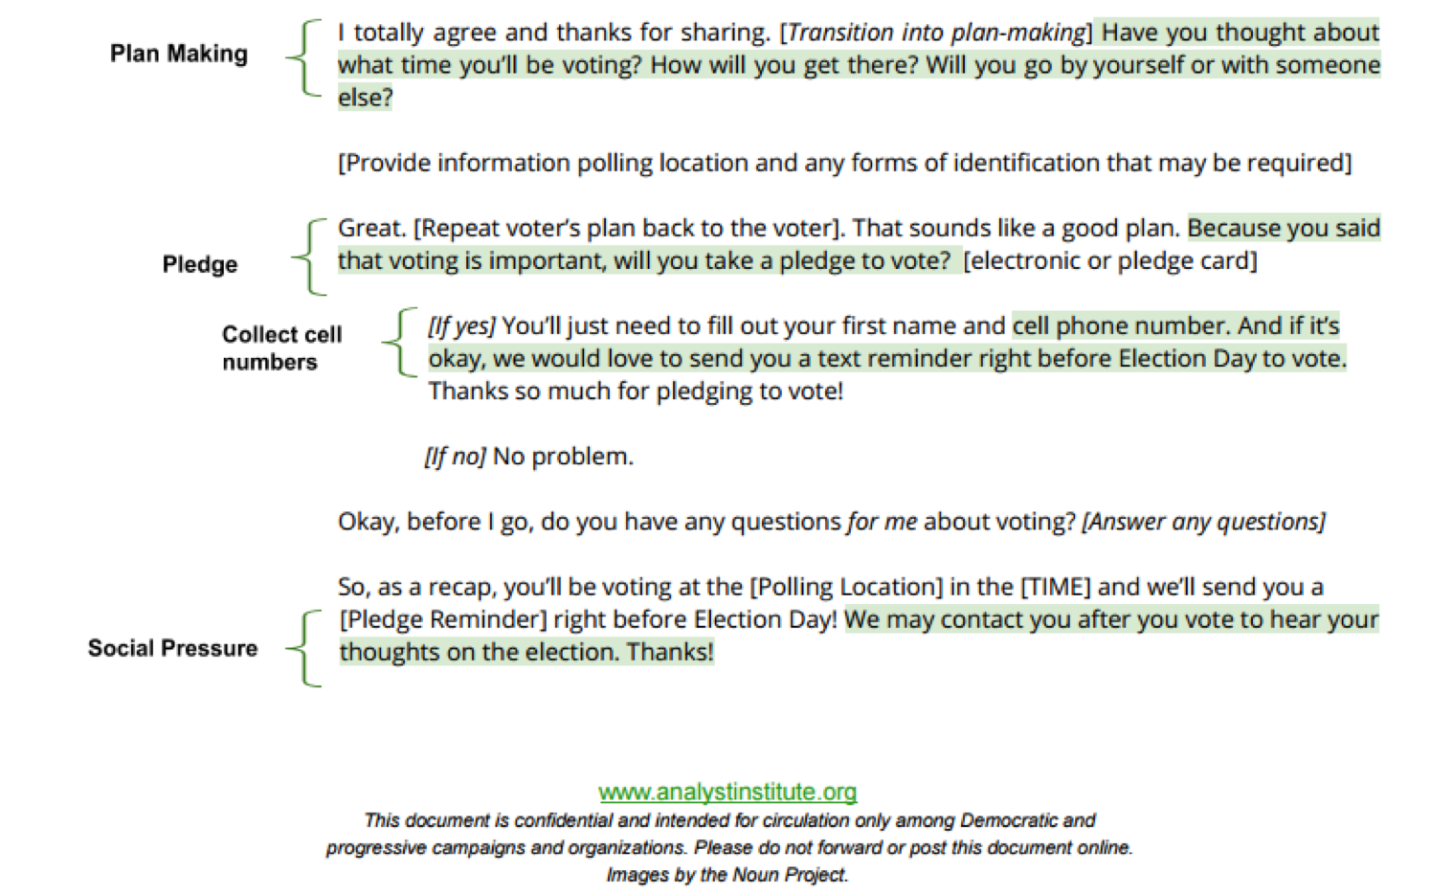
Activity: Scenario 1 Keep these points in mind:
Notes: • Local Touch
• Voter accountability
• Commitment to vote
• Plan-making
• Thanks for voting

Activity: Scenario 2
Notes:

