OFA
Effective Conversations
Part 3: Know your why

Simon Sinek’s Framework:

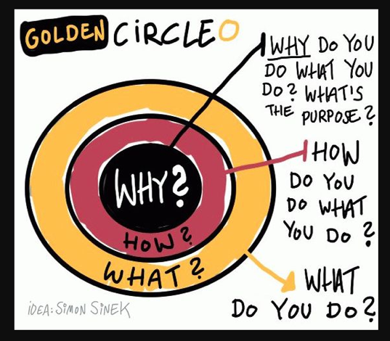

Critical incidents - “Events in your life that you recall being an important moment for you in clarifying what you believe.”
-- Stephen Brookfield

Framework #1: A framework to knowing your why:

Step 1 - Your critical incident

- When was the first time you remember standing up for something you believe in?

- When was the first time you saw something unjust?

- When do you remember feeling pride in something you worked hard for?

Step 2 - Root values

- Looking at your critical incident, what are the root values that you believe in?

Step 3 - Why is this important to you?

- Practice sharing your critical incident, as well as the root values that underlie it.

- How can you share this in a way that resonates deeply for others?

Activity #1: Steve Jobs’ keynote speech

For this activity, please view the following video: https://www.youtube.com/watch?v=UF8uR6Z6KLc&t=610s

What is Steve Jobs’ ‘why’?

What values are underneath his ‘why’?

Note: Use the values resource on the final page of this worksheet

How does he communicate it?Does it resonate?

Activity #2: Reflection Questions

When do you stay with ‘why’ in a conversation?

When do you move from ‘why’ to ‘how’ in a conversation?

When do you move from ‘why’ to ‘how’ in a conversation?

When do you move from ‘how’ to ‘what’ in a conversation?

Which phase of the framework comes most easily to you? Why?

RESOURCE #1: Values List (adapted from http://www.taproot.com/archives/37771):

Use this list of values to inform your critical incident -- which values resonate with your critical incident?

Abundance  Acceptance  Accountability Achievement  Advancement  Adventure  Advocacy  Ambition  Appreciation Attractiveness  Autonomy  Balance  Being the Best Benevolence  Boldness  Brilliance  Calmness  Caring  Challenge  Charity  Cheerfulness  Cleverness  Community  Commitment  Compassion  Cooperation  Collaboration  Consistency  Contribution  Creativity  Credibility  Curiosity | Daring  Decisiveness  Dedication  Dependability  Diversity  Empathy  Encouragement Enthusiasm  Ethics  Excellence  Expressiveness  Fairness  Family  Friendships  Flexibility  Freedom  Fun  Generosity  Grace  Growth  Flexibility  Happiness  Health  Honesty  Humility  Humor  Inclusiveness Independence  Individuality  Innovation  Inspiration  Intelligence | Intuition  Joy  Kindness  Knowledge  Leadership  Learning  Love  Loyalty  Making a Difference Mindfulness  Motivation  Optimism Open-Mindedness Originality  Passion  Performance  Personal Development Proactive  Professionalism  Quality  Recognition  Risk Taking  Safety  Security  Service  Spirituality  Stability  Peace  Perfection  Playfulness  Popularity  Power | Preparedness Proactivity Professionalism Punctuality Recognition Relationships Reliability  Resilience Resourcefulness Responsibility Responsiveness Security  Self-Control Selflessness Simplicity  Stability  Success  Teamwork Thankfulness Thoughtfulness Traditionalism Trustworthiness Understanding Uniqueness Usefulness  Versatility  Vision  Warmth  Wealth  Well-Being  Wisdom  Zeal

RESOURCE #2: Why, how, what indicators:

