Case Study: Resolution 124 in St. Louis

Introduction:

[PHOTO of ST. LOUIS]
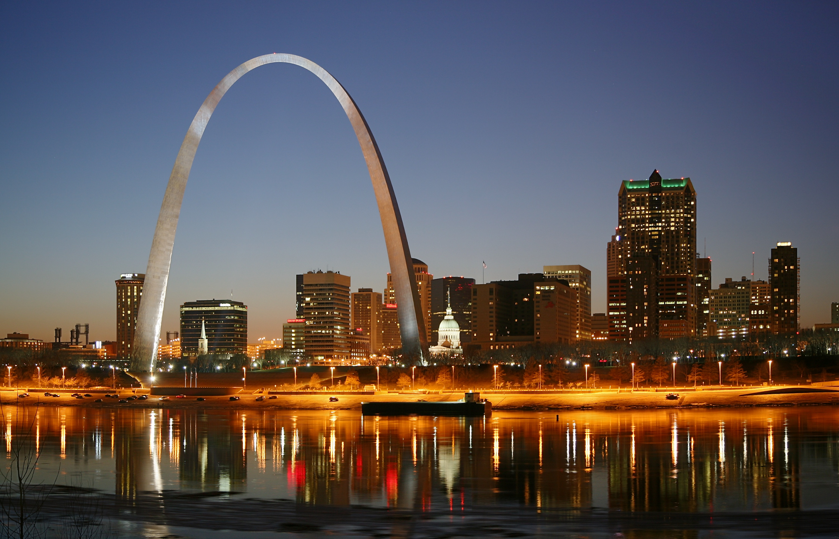

Welcome to St. Louis, Missouri! Perhaps most famous for its Gateway Arch, St. Louis is a city with a population of over 400,000 people, serving as the major economic hub of the greater St. Louis area. It is a city known for an economy centered around Health Care providers, manufacturing, and professional services. Perhaps most relevant to our study today is that St. Louis is home to Peabody Coal and Arch Coal, the largest private-sector coal companies in the world. This is where our case study begins.

St. Louis will become a “gateway” for you to explore a long-storied local issue advocacy campaign ran by a coalition fighting against climate change—and for clean energy. We’ll start with OFA St. Louis, led by Mr. James Page, whose challenges and ultimate successes will help you to envision what a local issue advocacy campaign looks like in practice.

The story takes place around the work directed by a strong local coalition to pass Resolution 124, which states that St. Louis will, “commit to transition to 100% clean energy in the form of wind and solar and energy efficiency measures within the electricity sector by 2035.” (citation). Resolution 124 was passed by the Board of Aldermen of the City of St. Louis on October 27, 2017.

Before we dive in, let’s take a look at some of the key players who were a part of this story.

Key players:

While countless individuals played a role in the success of Resolution 124, a few of them are highlighted below. Take a moment to read through their descriptions so that you’ll have more context going into the case study.

James Page—James Page is the OFA St. Louis Chapter leader. He is also a member of the OFA Board of Directors and Advisory Board, with a particular focus on grassroots engagement. James collaborates with regional progressive partners to focus his chapter’s organizing work on national, state, regional, and community issues. He was instrumental in participating in the coalition to pass Resolution 124.

Congresswoman Ann Wagner— Congresswoman Wagner is a member of the Republican party, representing Missouri’s 2nd district. Elected in 2012, she represents a Republican leaning district, and co-sponsored a bill that would forbid sending money to the UN to study climate change. In short, she has been identified as a climate denier.

Lewis Reed—Lewis Reed is the first first black man to be elected president of the Board of Aldermen for St. Louis. Originally elected to the city’s 6th ward in 1999, Reed has a special focus on revitalizing and growing his community. He served as the primary sponsor for Resolution 124.

Heather Navarro—Heather Navarro is the alderwoman for St. Louis’ 28th ward, serving since July of 2017. In addition to her role as Alderwoman, Navarro has served as executive director of the Missouri Coalition for the Environment since 2013. Under her leadership, her organization worked with coalition members like James Page towards the passage of Resolution 124. After her election, Alderwoman Navarro signed on as a co-sponsor on Resolution 124.

Missouri Clean Energy Coalition—The Missouri Clean Energy Coalition consists of around 17 different political, environmental, scientific, farming, and interfaith organizations. A broad coalition formed to, “grow our clean and renewable energy economy to reduce fossil fuel pollution, address climate change, and create jobs,” the coalition represents groups such as Sierra Club (represented by Andy Knot), OFA St. Louis (represented by Ken Denson and James Page), and the Missouri Coalition for the Environment (represented by Heather Navarro).

Part 1: Prelude

In 2013, OFA launched a campaign to call out Climate Change Deniers in Congress. The premise was that even though, “97% of climate scientists agree that climate change is real and man-made...too many of our elected officials deny the science of climate change.” [citation] OFA made it a key mission to call out climate change deniers, and to hold them to account for their positions, votes, and policies.

That year, OFA St. Louis Chapter Leader James Page—alongside OFA St. Louis Climate Lead Ken Denson—organized volunteers to begin to put pressure on recently-elected Congresswoman Ann Wagner of MO-02, a known climate denier.

Initially, James Page led a group of volunteers on an office visit, where they presented Congresswoman Wagner’s staff with a copy of the 1st National Climate Assessment.

In addition to office visits, he and his team used the following tactics:

- Climate denier rallies—OFA St. Louis used signs, pamphlets, lectures, and speeches to generate earned media and attempt to hold Congresswoman Wagner to account.

- Town halls— OFA St. Louis attended town halls with Congresswoman Wagner to attempt to highlight the issue of climate change.

- Social media— OFA St. Louis used Facebook and Twitter to promote events, as well as tweet/facebook at Congresswoman Wagner.

- Presenting climate denier unicorns—A special part of the OFA Climate Denier campaign, OFA St. Louis presented Congresswoman Wagner’s office which reads: “Congressional Climate Denier Award—For exceptional extremism and ignoring the overwhelming judgement of science.”

All of their work and actions culminated in an event that Congresswoman Wagner had been invited to. In preparation for the event, volunteers made signs calling her out as a climate denier, but when the event began, she had decided not to show up.

The result: many people were angry she didn’t show up, taking to social media to express their dismay. Initially, James identified this as a win. It felt good that negative attention was being shown to Wagner on social media.

But was it a win? Did it move the needle on the issue of climate change?

After taking a moment to stop and think, Mr. Page came to a disheartening conclusion—despite their best efforts, and despite how good their tactics felt at times, they weren’t generating wins or moving the needle.

It was time to re-tool, assess the results, and evolve. James didn’t want to do events just to feel good. He needed to change up the strategy and tactics to yield actual wins.

Key Concept 1: Know the story of your city and assess the efficacy of your current actions.

Part 2: How can we move the needle?

Changing the strategy

James Page decided to re-tool OFA St. Louis’ efforts towards something they could move the needle on—he decided to go local—away from Republican leaning MO-02 to his home district of Democratic leaning MO-01.

Knowing the impact of companies like Peabody Coal, Arch Coal, and Ameren on his community and the environment, he decided to move towards a resolution that moved St. Louis to 100% clean energy by 2035—the resolution to be called Resolution 124.

OFA St. Louis, however, was made up of a passionate group of volunteers—some holding jobs, all taking care of families and personal affairs, and many without the technical expertise on the issue of clean energy. They knew they couldn’t do it alone—they needed a coalition of partners.

Knowing this, they enlisted the help of Andy Knot (Sierra Club) and Heather Navarro (Missouri Coalition for the Environment).

James Page, Ken Denson, Andy Knot, Heather Navarro, and others had to begin pooling their knowledge of organizations, elected officials, and key players in the community.

***

Brainstorming sessions and coalition building

Knowing the need to build a strong coalition in support of clean energy in St. Louis, OFA St. Louis held brainstorming sessions. During these sessions, they:
- Put together names of organizations each individual felt familiar with and had connections to
- Researched and calendered each group’s upcoming meetings
- Planned to show up at these meetings to build relationships with individuals representing the organizations and make asks to support clean energy

James says that if there was ever a lesson learned from brainstorming, it’s that you can’t simply brainstorm. You must show up—relationships are everything and start anywhere.

By the end of brainstorming and planning on building the coalition, it was wide and diverse, representing everyone from the NAACP to faith-based groups and farming communities.

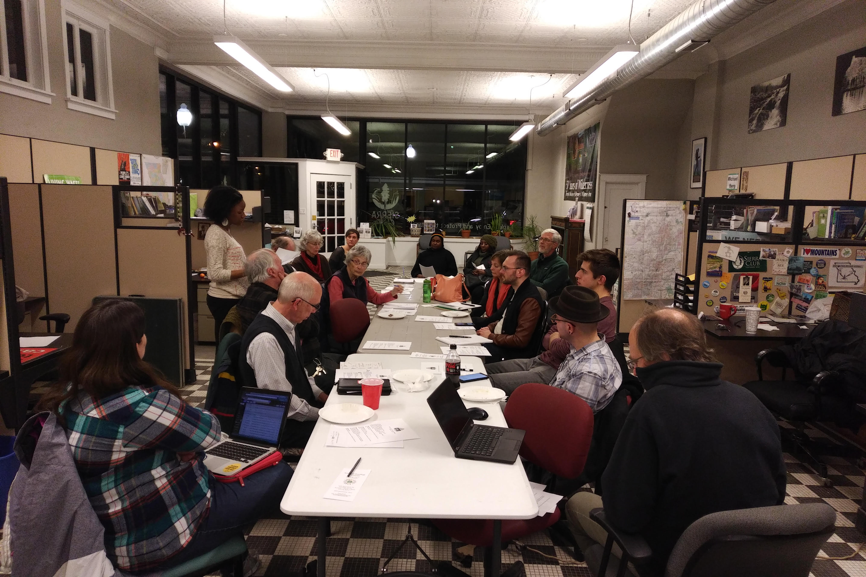

***
Just what kind of coalition?

From brainstorming, the newly formed and fledgling coalition in favor of Resolution 124 decided the parameters for growing their coalition.

They settled on t6 principles for building a coalition:

- The coalition has to be overwhelming—It should represent the broad society of the community as a whole, including political, faith-based, economic based, and social groups.

The coalition built to support Resolution 124 represents a large coalition of environmental, political, faith-based, academic, and scientific interests across St. Louis. It is the Missouri Clean Energy Coalition:

Missouri Coalition for the Environment ;Missouri Sierra Club; Renew Missouri ;Jewish Environmental Initiative: a committee of the Jewish Community Relations Council of St.Louis; Missouri Interfaith Power & Light; Ethical Society of St. Louis; Mid-Missouri Peaceworks/Missourians for Safe Energy; Labadie Environmental Organization; Union of Concerned Scientists; Central Reform Congregation; Earthdance Farms; Women’s Voices Raised for Social Justice; Populists in Action; 350KC; Organizing for Action – Missouri; Shir Hadash Reconstructionist Community; and Climate Parents.

- Has to apply gentle pressure—The coalition should use tactics that build relationships with elected officials, community members, and businesses to build support—as opposed to those tried earlier (i.e. Climate denier unicorns).

- The coalition should be well organized—The coalition should have an ultimate goal, a strategy behind that goal, and tactics that assist that strategy. Division of labor should focus on the expertise of each representative in the coalition. Coalitions should be honest on knowledge and resources they are missing and seek to gain them from different sources.

GOAL: To propose and pass Resolution 124, committing St. Louis to transfer to 100% clean, renewable energy by 2035.

- The objective should be logical—The objective (or goal) should be won that can move the needle on the problem the community faces.

- The coalition should benefit with the community—The goal should be one that solves a problem for the community and the coalition at the same time.

- The coalition should build relationships with elected official over time—The coalition should seek to identify key decision makers it can build relationships with, collaborate on the goal with, and ultimately move the needle on the issue with.

Key Concept 2: Begin building relationships with community members, elected officials, and organizations. Show up to their events and build a coalition around a strong goal.

Part 3: The coalition is built, the goal is set—now what?

A lack of expertise

The coalition was built and the goal was set, but something was missing. James Page and his colleagues had begun the legwork towards passing Resolution 124, but they lacked strategy that utilized the expertise of folks who organized before them, and of professional policy wonks who knew every minute detail of the the issue at hand.

To be sure, it can feel jarring to invite a paid expert from “outside” your community to join your coalition—but as James found, their coalition lacked the very legislative experience they needed.

They had organizing experience, but they needed they nitty gritty expertise on the issue that only certain groups and professionals can give.

Holding true to the principle that their coalition should be well-organized, they invited paid staff and groups with that experience to assist them.
***

The strategy

James and the coalition knew that they needed a strategy that would assist the goal they had set out to accomplish.

They settled on this strategy to achieve their goal of passing Resolution 124:

- Look for people with resources that you need—I.E. paid staff with a special focus in legislative experience
- Ask for advice—Focus on asking community member, organizations, and businesses for advice. In the case of Resolution 124, the coalition asked city officials which alderpersons would be good to work with.
- Show up—Show up at any meeting where you can build relationships with decision makers, partners, or local experts.
- Don’t reinvent the wheel—The St. Louis coalition didn’t reinvent the wheel. They researched similar resolutions that were passed in other cities around the country.
- Rely on other’s strengths where you lack expertise—OFA St. Louis relied on the Sierra Club to help craft and give recommendations on Resolution 124.
- Build relationships with key decision makers—Build relationships with the local government officials you need to pass your proposal or move the needle on it. The St. Louis coalition built relationships with alderpersons who eventually were asked to, and did, sponsor Resolution 124.

Key Concept 3: Gain expertise on the issue and set your strategy.

Part 4: The tapestry of connection

With the right strategy, you’ll get some detractors…and some friends too

Ameren, Arch Coal, and Peabody Coal were quick to invest in efforts to oppose the burgeoning coalition. The coalition, however, was overwhelming by this point.

Tactically, the coalition had asked city officials about alderpersons they should build relationships with around their goal, and begun building those relationships. One such alderperson they began building a relationship with is Lewis E. Reed, President of the Board of Aldermen of the City of St. Louis. In 2017, after being presented with the proposal for the resolution, and with the weight of the coalition to collaborate with him, Mr. Reed proposed the resolution officially before the Board of Aldermen.

That is not to say that the coalition came upon this outcome seamlessly.

Every single individual and group had to rely upon their expertise and relationships—and to show up in those relationships with that expertise—in order to succeed.

James Page, for example, relied on a group he leads called the, “Holy Ground Collaborative.” The Holy Ground Collaborative is a highly diverse group of faith based organizations consisting of Jewish, Unitarian, Episcopal, Presbyterian, and more faiths. Had Mr. Page not engaged this group to join the coalition, it wouldn’t have been interfaith.

Heather Navarro, for example, relied on her deep roots in the environmental community, and her ties to St. Louis, to bring in a diverse array of expertise to the coalition. Had Mrs. Navarro not engaged her contacts to join the coalition, it might not have included the expertise and gravitas it needed.

All this to be said—each individual and organization brings a tapestry of personal relationships with it.

Key Concept 4: Pull in everyone you know—create a rich tapestry of connections.

Conclusion

On October 27, 2017, Resolution 124 passed the Board of Aldermen of the City of St. Louis.

It was sponsored by President of the Board of Aldermen Lewis E. Reed and included 11 co-sponsors (including Heather Navarro).

It is a resolution—triumphant to the cause of fighting climate change—passed in a singular moment, but only made possible by the hard work over years by those dedicated to seeing its passage.

Artifacts:

- NBC Article
- Agenda—Beyond Coal Meeting
- Social media post and hashtags
  - https://twitter.com/KenDensonSTL/status/906180534396739584
  - #STL100
  - #readyfor100
  - #showmecleanenergy

-------------------------------------------------------------------------------------------------------------------------------------------

#########DRAFT ENDS HERE#########

Key concepts:
  - Key concept 1: Know the story of your city; assess efficacy of current actions
  - Key concept 2: Start showing up to events; begin building relationships with elected officials (eventual goal: coalition has to be overwhelming, has to apply gentle pressure, well organized, logical, has to be a benefit for the community, building relationships with elected officials over time)
  - If you find there is a coalition, don’t assume they are doing it right - (who are they affiliated with?)
  - Key concept 3: Gain expertise on the issue
  - Key concept 4: Begin pulling in everyone you know
  - Tapestry of connections

Key players: (bio & overview)
- Ann Wagner
- James Page
- Lewis Reed
- Missouri Clean Energy Coalition (Heather Navarro, Andy Knott, Ed Smith, Ken Denson)

Context of issue (resolution 124)
- St. Louis—

Storyboard:
- In 2013, OFA launched Climate Deniers Program
- James Page and OFA STL decide to call out climate denier Congresswoman Anne Wagner
- Tactics used: Unicorns (pictures), townhalls, printout of climate change pamphlets
- None of these tactics worked–he asked himself, given that the Member of Congress seemed immovable, at least in the short-term, what would actually move the needle on the whole climate/clean energy agenda?
- Answer–Local action, specifically Resolution 124: 100% clean energy in St. Louis by 2035

***

- They wanted to introduce a resolution to the Board of alderman of St. Louis on this proposal, but they couldn’t do it alone–they needed a coalition of partners
  - Overwhelming support
  - Able to apply gentle pressure
  - Well organized
  - Logical
  - Benefit with the community
  - Can build relationships with elected officials over time
- Key players in the coalition
  - Ken Densen—OFA STL Clean Energy Lead
  - Andy Knot—Sierra Club
  - Heather Navarro—Alderwoman for ward 28 in St. Louis/ED Missouri Coalition for the Environment
  - + others
- Brainstorming sessions—put together names of orgs they felt familiar with and had connections to. Tried to get groups like NAACP and other well-known groups to support Resolution 124
- We knew we had some detractors like–Ameren,Arch Coal,Peabody Coal
- We had take a look in the mirror—Our coalition lacked legislative expertise, but good organizing expertise.
  - SOLUTION—Paid staff, groups with nitty gritty expertise
- Personally for James Page, the groups and resources that he had access to became immediately relevant
  - Holy Ground Collaborative, for example

***
- Strategy
  - Looked at other similar resolutions that were passed in other cities around the country
  - Did not reinvent the wheel of resolution 124
  - Relied on sierra club colleagues that have chapters across the country, sent to members, created resolution
  - Got involved with aldermen
  - Got people to sponsor it
- Arch coal, peabody coal launched their forces against the resolution - they knew the group (detractors)

5-6 artifacts
- NBC article
- Picture of coalition meeting
- Picture of St. Louis
  - https://commons.wikimedia.org/wiki/File:St_Louis_night_expblend.jpg

- Missouri MGO EMT letter
- http://www.cleanairmissouri.org/
- Social media post

  - https://twitter.com/KenDensonSTL/status/906180534396739584
  - #STL100
  - #readyfor100
  - #showmecleanenergy

Timeline -- need from Mr. Page

Key players -- need from Mr. Page
- 3-4 key players

Grey box -- Strategy 1/Strategy 2

OFA Case Study

State/Local Campaign Analysis: St. Louis, MO

This is a description of St. Louis demographics, economy, populations, and any other fun facts relating to the issue campaign.

This is a description of the political make-up: Aldermen/alderwomen, congressional districts, and the like.

The Local Campaign in St. Louis

Background:
Include date, and more about Resolution 124. Include key players (Ann Wagner, Alders)

The Road Ahead:
This includes where it is so far and a little bit of the political climate as to how it’s gotten there.

Key Decision Makers for the Clean Energy Resolution

Ann Wagner, 2nd Congressional District, (Suburban St. Louis?)

XXX, Title (description of area)

XXX, Title (description of area)

Key Players for the Clean Energy Resolution

The key players should go here. (currently listed below)

___________________________________________________________________________

Assets needed:

- Tweets, facebook posts, messaging, blogs, or quotes from Mr. Page about strategy
- Any news articles for analysis
- Timeline of tactics
- Pictures

___________________________________________________________________________

Worksheet
Issue Campaign Analysis

- Analyze the issue background and resources.
- Use this worksheet to outline the successes and problems with the organizing strategy -- what was effective in pushing St. Louis towards clean energy? What was not effective?
- As you identify problems and solutions, propose solutions -- if you were an organizer working towards clean energy in St. Louis, how might you organize around this issue differently?

Purpose
To get 100% clean energy in St. Louis

People
- James Page -- OFA leader in St. Louis, lead organizer on campaign
- Ann Wagner -- US Congresswoman, Missouri’s 2nd Congressional District
  - Republican
  - Climate denier
- Ken Dempson -- Founding member of the Missouri Clean Energy Coalition
- Andy Knot -- Sierra Club
- Phil -- Renew Missouri
- Heather Navarro -- Ward 28 Alderwoman, Missouri Coalition for the Environment
- Kyra Woods -- Sierra Club clean energy organizer
- Lewis Read -- President of the Board of Aldermen in St. Louis

Partners
- Missouri Clean Energy Coalition
- Missouri Coalition for the Environment
- OFA St. Louis - OFA Climate Team
- Interfaith Power and Light
- Renew Missouri

Other groups
- Ameren
- Arch Coal
- Peabody Coal
- St. Louis Law Enforcement

Tactics
- Staff visit
  - To present National Climate Assessment
  - St. Louis County law enforcement present
- Rally signs
- Lectures
- Speeches
- Social media
- Event inviting Ann Wagner
  - Tactic deployed to use rally signs tagging her as a climate denier
- Building relationships with elected officials
- Coalition building
  - Grassroots and people with experience and careers
- Lectures on climate at churches
- Local official relationships

Points to drive home
- 1) Build a serious coalition of partners
- 2) Be nimble and make sure that you have expertise in the partnership
- 3) Build a tightly woven, close-knit tapestry of resources
  - EX. Sierra club chapters
  - Alderman
  - Sponsors

- 4) Look

