Issue Campaign Analysis: Background

The Island of Harmonia is a peaceful island off the east coast of the United States. It is about the size of Maine and has a population of 400,000 people. A little over 300,000 people live in the capital of Harmonia – Shellsville, with the rest of the population scattered throughout the agricultural communities across the island’s east coast. The economic core of Harmonia is nuts. Cashew nuts to be precise. They are grown and processed throughout the island and then exported to the mainland mainly for use in exotic desserts and many of the ice creams produced by Bob and Jay’s brand of ice cream. There is a thriving summer tourist business, but the nearly $1 billion in nut sales are the dominant theme in Harmonian life.
The Capital of Harmonia is Shellsville. Shellsville is the export point for Harmonia’s main export of Cashew nuts, and is also the landing point for many summer tourists. Harmonia Island is also home to two state universities: the University of Shellsville, located in Shellsville, and Harmonia University, located in Stuckey County on the east side of the island.
The Island is governed by a state legislature comprised of a State House of Representatives and a State Senate. State Representatives are elected every two years, and State Senators are elected every four years. The state is divided into 30 state house districts, each represented in the legislature by one State Senator and two State Representatives. Harmonians are known for being free thinkers, and their state legislature shows it—both the State House and State Senate are evenly split three ways between Democrats, Republicans and Independents.

The Issue Ecosystem on Harmonia Island

Minimum Wage:

Background:
In the most recent state elections, the voters of Harmonia approved a ballot measure declaring that the state legislature should raise the minimum wage to a living wage (based on the Economic Policy Institute’s regionally sourced cost-of-living and inflation calculations). The ballot measure passed by 2%, and is nonbinding, meaning its passage is a message to the state legislature about the will of the voters, but does not actually force the legislature to pass or even vote on the issue.

Recently, House Resolution 248, a bill to raise the minimum wage to a living wage, was introduced by State Representative Olivia Waggoner. Rep. Waggoner is a retired museum curator and represents the Arts District in urban Shellsville. HR 248 originated in the Finance committee, where it was approved by a 4-3 vote. The Speaker of the House has signaled that she intends to bring the issue to the House Floor for debate and a vote.

The Road Ahead:
Should HR 248 make it to the House Floor for a vote, it must get a Yes vote by 31 of 60 Representatives in order to pass. Current analysis shows that 28 Representatives have voiced their support for the bill. Twenty-six representatives have voiced their opposition. This leaves six Representatives who have not publicly stated their opinion. If HR 248 is to pass, three of those six undecided members must vote yes.

If HR 248 is approved by the House of Representatives, it must then be approved by the State Senate with a two-thirds majority. This means that 20 of 30 State Senators must vote yes in order to pass the bill. So far, 17 State Senators have voiced their public support, and nine have voiced their opposition to the bill, leaving four Senators undecided. Three of the four must vote yes in order for the bill to pass. Harmonia Governor Tatiana Wheatley has expressed a desire to follow the will of the voters and the legislature on all issues, but has not expressly endorsed raising the minimum wage.

Harmonia DREAM Act:

Background:
Meanwhile, in the same recent election, voters also approved a ballot measure declaring that Harmonia should adopt a state DREAM Act. The island has a large undocumented community and the bill would allow state universities to admit undocumented students who were brought to the island by their parents before the age of 16. The ballot measure passed by 15%, and is also nonbinding.

Recently, House Resolution 694 was introduced by Representative Tina Alam. The bill was approved in Committee, and the Speaker of the House has signaled that she intends to bring it to the floor for debate and a vote.

The Road Ahead:
If the DREAM Act makes it to the floor for a vote, it will require yes votes from 31 out of 60 representatives. So far, 30 have voiced their public support for the DREAM Act, and 23 have voiced their opposition. That leaves 7 undecided Representatives that could be the deciding vote. In order for the DREAM Act to pass, just one of these seven needs to vote yes.

The State Senate has a narrow but firm majority of Senators who have signaled their support for the DREAM Act. It is expected to pass the Senate if it passes in the House.

Governor Wheatley has expressed a desire to follow the will of the voters and the legislature on this topic. She is also proud of her record on education, noting frequently that she has always supported any measure that expands access to higher education, whether as governor or during her time in the State Senate 8 years ago.

Key Decision Makers for the Minimum Wage Bill

Swing Votes on Minimum Wage in the Harmonia House of Representatives:

Ken Matsushita, District 6 (Harmonia University and surrounding area)
Matsushita is a real estate developer who ran and won on his business record, which has driven property values up in Stuckey county, surrounding Harmonia university. Higher property values have been good for homeowners, though many students and low wage workers have been priced out of rental housing that in the past was affordable. Matsushita has stated that more real estate development will lead to greater prosperity for all via the trickle down effect. He is currently serving his first term in the Harmonia House of Representatives.

Stella Magaña, District 9 (Suburban Shellsville)
Rep. Magaña is the President and CEO of Harmonia Hotels, a chain of tourist-centric resorts in Harmonia, with four resort locations on the west coast and one on the east coast. Rep. Magaña has a reputation as a no-nonsense, no-drama businesswoman, and unlike many hotel moguls, is notorious for her extremely frugal lifestyle. She has frequently noted publicly that the best thing she can do with her hard-earned wealth is put it away so her children and grandchildren never have to worry, or to pay it forward by contributing to worthwhile charitable causes.

Leo Shipp, District 12 (Suburban Shellsville)
Rep. Shipp is a corporate attorney with 20 years of experience litigating on behalf of large companies specifically in the Hospitality sector. He was first elected two terms ago by a very slim margin, but gained the endorsement of the Chamber of Commerce for his reelection campaign, which he won handily.
Miranda Sheldon, District 12 (Suburban Shellsville)
Rep. Sheldon is a dentist in suburban Shellsville, where she was born and raised. She is a first term representative, and like her fellow 12th District Rep. Shipp, she was elected by a slim margin – so slim, in fact, that the race went to a recount before it was called in her favor by just 14 votes.

Rashida Knox, District 20 (Rural Eastern Harmonia)
Rep. Knox started her career 15 years ago as a labor organizer who organized farm workers on Harmonia’s cashew farms. From there, she became a pillar of her rural community, rising from organizer to activist to public figure known for standing up for her fellow rural Harmonians--especially the most vulnerable among us. She is currently serving her fourth term in the State House of Representatives.

Rodrigo Haskins, District 29 (Rural Eastern Harmonia)
Rep. Haskins owns and operates Haskins Grove, the largest, most profitable cashew farm in Harmonia. The farm has been in his family for generations, but only when Rep. Haskins took over did it become the enterprise it is today, with a yearly net profit nearly 60% higher than any other cashew farm on the island. Rep. Haskins is currently serving in his fifth term in the State House of Representatives.

WHERE IN SHELLSVILLE IS RICHARD ARAUZ? | Oct. 14th
BLOG POSTS FROM THE CAPITOL BY DAILY HARMONIAN REPORTER, RICHARD ARAUZ

OCTOBER 14TH, 6:00 PM – Discussion on the Lawn: DREAM ACT
Last night I attended an educational discussion on the DREAM Act on the lawn of the Capitol building. The Harmonia DREAM Act is a bill recently introduced in the State House of Representatives which would allow state universities to admit undocumented immigrants who were brought to the island before the age of 16. According to the Harmonia Center for Immigration Policy, the DREAM Act may impact up to 10,000 immigrant youth across Harmonia.
The discussion was well attended—I counted 55 attendees—and created a better understanding of the bill and what people can do to support this important issue affecting thousands of bright young immigrants today. At the end of the evening, the discussion organizers signed up all attendees for an October 23rd rally outside of the Capitol. The rally seeks to call the attention of the State House of Representatives, which will reportedly debate and vote on the issue on the same day. They also signed people up for a volunteer phone bank happening tomorrow and a sign-making party happening on October 20th. Learn more about these upcoming events using #ShellsvilleToday.
If you want to learn more about the state DREAM Act, access the Harmonia Center for Immigration Policy web site: HCIP.org. The Daily Harmonian has also covered the issue. Check out articles under the community section of the website: DailyH.com.

OCTOBER 14TH, 8:00 PM – Movie Showing: Minimum Wage Campaign
After the discussion I headed over to the Emporium Café in the Arts District, where the Raise the Minimum Wage Campaign showed the movie Working Dignity. The short documentary portrayed the stories of four minimum wage employees in Nebraska who struggled to make ends meet. Activists in Nebraska organized for years, ultimately succeeding in raising the minimum wage to a living wage for all residents of the state.
The documentary had a strong story and was well made. (If you have Netflix, I recommend you watch it.) However, I am not convinced this story translates very well to the island of Harmonia. After all, how similar is Nebraska to Harmonia Island?
After the documentary was over, the group did not quite explain what their organizing plan was. When one attendee asked what people could do to make this happen here, they said: “We have to show the State House that the community overwhelmingly supports this issue.” But by the end of the movie, there were only nine of us in attendance – so I’m skeptical that this “overwhelming support” is there.
A few attendees left before the movie was over. I wanted to reach out and find out why, so I asked the organizers if they had used a sign-in sheet or otherwise captured the contact information of the small group of people who attended the event. They had not.

FROM TWITTER

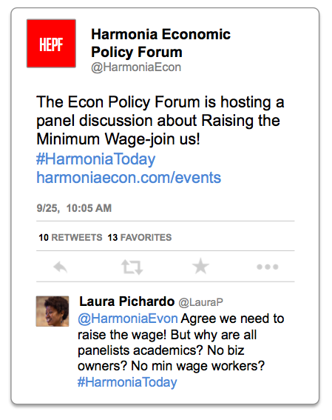

FROM TWITTER
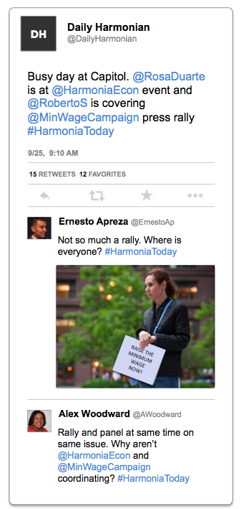
FROM TWITTER
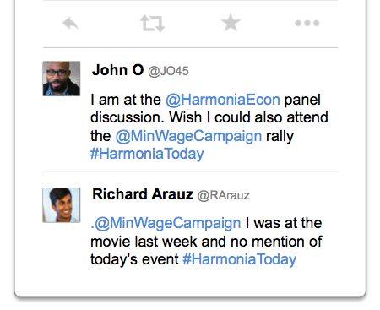
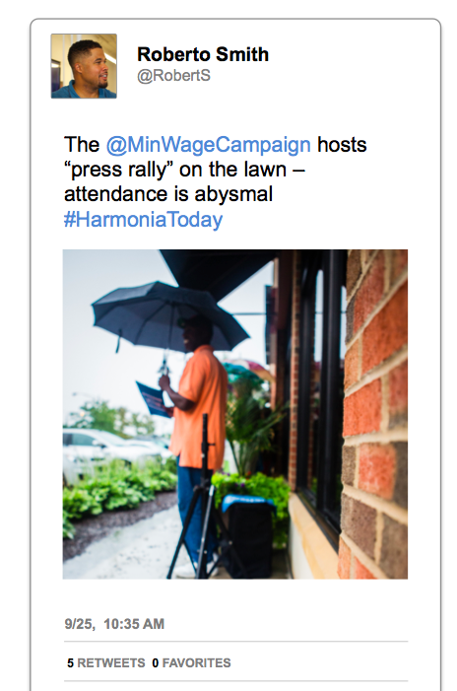

FROM TWITTER
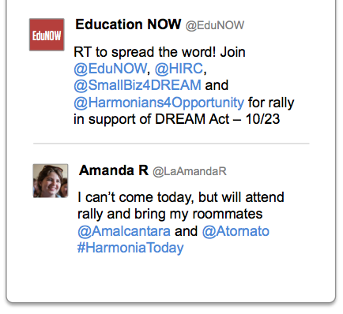
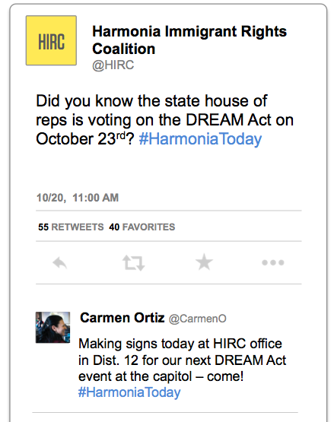

THE DAILY HARMONIAN – Online
Harmonians’ Number 1 News Source

State House of Representatives Approves Harmonia DREAM Act

By Curtis Olson | Oct. 23rd, 2015
This morning, the Harmonia House of Representatives approved HR 694—also known as the Harmonia DREAM Act—saying that this legislation is necessary to promote access to education among the thousands of undocumented college-aged people who reside in Harmonia. The resolution passed by a vote of 33-27.
The State Senate is expected to introduce an identical version of the bill today, where all sources close to the Education Caucus predict it will be easily approved. Governor Tatiana Wheatley has signaled she will sign the bill into law upon arrival at her desk. “I have a long history of supporting expanded access to higher education among all young Harmonians. I commend the State House for approving the bill, and expect the Senate to waste no time in doing its part. I look forward to making the DREAM Act the law of the land in Harmonia.”
The vote came on the heels of a rally attended by over 300 people in front of the Capitol on Friday morning. The rally was organized by various organizations, including the Harmonia Immigrant Rights Coalition, Education NOW, Harmonians for Opportunity, and Small Business for the DREAM.
“We were organizing and working hard to make this a big rally, to show that the vast majority of Harmonians wanted this resolution passed, and it paid off,” said Alexandra Florentino a member of the Harmonia Immigrant Rights Coalition.
About 325 people attended the event, and according to organizers, all 30 Harmonia districts were represented.
But the DREAM Act was not the only issue on the agenda. The State House voted against raising the minimum wage to a living wage. “I hope we get there,” said Rep. Rodrigo Haskins, who supports raising the minimum wage but did not vote in support of this particular bill. “We had a historic moment of widespread enthusiasm for the DREAM Act, so we seized it. Many members do not feel they have enough information about the Minimum Wage bill to vote yes and feel confident it will help their constituents. We can get to that another day and give it the due diligence it deserves at a time when we feel more confident that the senate will also be able to do its part. But for now, the DREAM Act was a much more urgent matter on which we had to focus all our capital and energy,” said Haskins.
On the morning of the vote, a group of six students from the University of Shellsville representing the Raise the Minimum Wage Campaign locked arms and physically blocked the east entry to the Capitol, delaying the start of the session by forcing officials to enter through the west entrance. They were eventually removed by Capitol Security.
“Blocking our entrance and our ability to represent our people does not get you anywhere,” said Rep. Stella Magaña, who also voted against raising the minimum wage. “This is an important issue worthy of debate, but it is clear that this particular bill is being pushed only by extreme groups with their own underlying agenda, who have no responsibility to do right by ordinary Harmonians.”
“I am disappointed that the State House voted against raising the minimum wage. Their vote shows that they care more about profit than human beings,” said Carlos Ortega, an organizer with the Raise the Minimum Wage Campaign. “Harmonians overwhelmingly support this bill and the powers that be yet again ignored us,” added Ortega.

High school student Megan Estafano was one of the more than 100 students who stood outside the Capitol. Her sign, which used #TheTimeIsNow, showed her support for the state DREAM Act.
“The time is now to allow young people like me, who are in Harmonia undocumented, to have access to an excellent public education.” Estafano said. “We just want to pursue our dream careers and contribute to society.”
While a number of rally participants also said they supported raising the minimum wage, they explained that the DREAM Act was a priority. Many were not aware the minimum wage vote was expected on the same day as the DREAM Act vote. “I think it is important for all Harmonians to earn a living wage,” one rally goer, Marcus DeGarza said. “but I am focused on the DREAM Act now. We’re in a historic moment.”
The President of the State Senate expects debate on the DREAM Act to start on Monday morning.
The Daily Harmonia welcomes thoughtful, respectful and relevant comments that contribute to a public dialogue. View our full comment policy to contribute to the conversation.

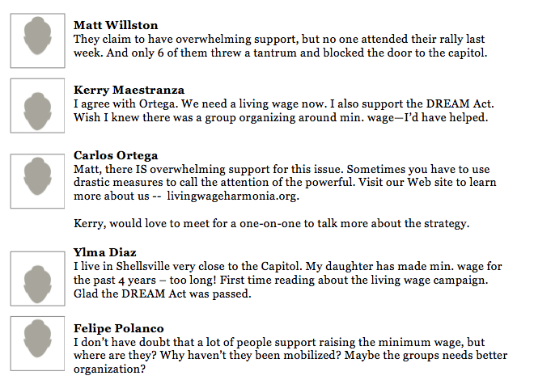

InsideTheLegislature.com
You deserve to know what’s happening inside the walls of the Capitol. We report it.

October 23, 2015: Shellsville—This morning, just one week before the end of the legislative session, the Harmonia House of Representatives voted on two distinct issues. It approved the Harmonia DREAM Act, which would allow state universities to admit undocumented immigrants who were brought to the island under the age of 16, and did not approve a bill to raise the minimum wage to a living wage.
As of Thursday afternoon, sources close to Rep. Olivia Waggoner, the sponsor of the Minimum Wage bill, said she was still scrambling to shore up enough votes to pass the bill. Together with her team of staff analysts, Rep. Waggoner predicted that 28 Representatives were certain to support the bill, and 26 were certain to oppose it, which left 6 undecided members who could be the final deciding votes. The bill required three of those members to vote yes in order to pass, but only one member, Rashida Knox of District 20, did so.
We caught up with each of these key Representatives to ask why they voted the way they did. Here’s what we heard.
Ken Matsushita, District 6 (NO) – “As a public servant, I have an obligation to apply my business expertise to the business of our state. And as a businessman, you have to make decisions based on hard facts and reliable data – not conjecture. I have seen no evidence to support the idea that higher wages will improve the economy of Harmonia. The best thing I can do for the people of Harmonia is to make sure the economy is healthy, so I voted no.”
Stella Magaña, District 9 (NO) - “As a state representative, I value the input of my constituents. In my daily work, I make it a point to listen to what my constituents have to say about the issues, and quite frankly, I heard very few signs of support from my district on raising the minimum wage. You may have seen an advertisement in the Daily Harmonian targeting me as ‘out of touch’ and a ‘corporate fat cat,’ claiming that if I don’t support this, I don’t support working people. That is just preposterous. Any credible group would look at my background and know that I know what everyday Harmonians are going through. I am here for middle class Harmonians – I just think there has to be a better way to look out for them, and I’m looking forward to working with my colleagues to find solutions that result in an improvement of their daily lives.”
Leo Shipp, District 12 (NO) – “The most important thing to me is that I represent my constituents well. And I heard loud and clear that my constituents in District 12 did not support this bill. I met with citizens from all across my district, many of them small business owners with a very real concern that the burden of paying higher wages would put them right out of business. I could not in good conscience vote for something that would directly harm District 12 businesses – the lifeblood of our economy.”

Miranda Sheldon, District 12 (NO) – “I believe that both the Minimum Wage and the DREAM Act are important issues deserving of our debate. Based on what I heard from my constituents, I must say, both issues are extremely polarizing and controversial. At the end of the day, I felt that passing the DREAM Act—which would do nothing but help a young generation of bright future leaders—would put me on the right side of history. I want to be on the right side of history. The Minimum Wage is an issue that can be tabled for another day, and I did not feel I had enough information about the bill or enough support from my district to vote yes on that issue. I look forward to getting to the Minimum Wage issue at a future date – but for today, I am extremely proud to have been part of this historic moment of passing a DREAM Act that will impact thousands of Harmonians.”
Rashida Knox, District 20 (YES) — “Look – I was elected to stand up for my values. I value working people, I value the contribution of immigrants to Harmonia, and I value expanded access to higher education. I voted yes for both issues, and I am disappointed in my colleagues who couldn’t summon the courage to do right by Harmonians and vote to raise the minimum wage. They are not leaders—they made a politically expedient decision in order to preserve their own seats in the legislature.”
Rodrigo Haskins, District 29 (NO) — “Listen, as I told all the other reporters: I hope we get there on the minimum wage. I believe we can. But we had a historic moment of widespread enthusiasm for the DREAM Act. And we knew if we led, the Senate would follow and the Governor would approve. It was on our shoulders. So we had to seize that opportunity. I had to focus my own capital and my own energy on ensuring we seized this historic moment. The minimum wage bill can wait for another day when we can really give it due diligence. I encourage my colleagues to take a serious look at the minimum wage issue so that next session, we can have a proper, intelligent debate and make the decision that is best for all Harmonians.”
For more information about your Representative’s voting record, view their voting history at insidethelegislature.com/record.

WORKSHEET
Issue Campaign Analysis

- Working with your group, analyze the issue background and media stories from the Harmonia state legislature.

- Use this worksheet to outline the problems with the organizing strategy that ultimately failed to persuade the State House to approve a bill to raise the minimum wage.

- As you identify problems with the organizing strategy, propose solutions -- if you were an organizer in support of raising the minimum wage in Harmonia, how would you organize around this issue differently?

Observed Problem with Organizing Strategy | Proposed Solution
#1
#2
#3

Observed Problem with Organizing Strategy | Proposed Solution
#4
#5
#6
#7

